**Assignment 1:**

**COMP1341 (Introduction to Web and Database Development)**

**Assignment 1**

**Semester 1 - 2018/2019**

**Student number: 18006277**

□ I do not want my work to be used anonymously to help future students

**Website description and a working URL for the published Website**

Website URL: <http://garb1-18.wbs.uni.worc.ac.uk/>

GitHub Link: <https://github.com/Garb18/COMP1341-Front-End-Web-Development>

The website I have created is a fictional cattery which sells purebreds and offers an adoption service for rescue cats. The different pages I included are:

1. Home Page (index.html)
2. About Us (about_us.html)
3. A list of current rescues (rescues.html)
4. A page for each rescue currently on offer
   1. Mable (Mable.html)
   2. Majick (Majick.html)
   3. Mango (Mango.html)
   4. Oscar (Oscar.html)
5. Two video pages for respective rescues
   1. A video of Mable (mVideo.html)
   2. A video of Mango (sVideo.html)
6. A contact us page (contact.html)
   1. Nested in this page is a link to a contact form (contact_form.html)
7. A mailing list sign up page (mail_list.html)



In addition to the HTML pages I included in my website I also included:

1. A CSS style sheet which included the styling for all my HTML pages (stylesheet.css)
2. Three JavaScript files
   1. Email.js – Ensures that emails the user inputs on my two forms are matching
   2. Greeting.js – A greeting message on index.html which changes based on the time of day
   3. Slideshow.js – Controls an automatic sideshow on each of the rescue pages. Does not work when linked externally, so the script is also included directly in the relevant HTML pages with the <script> tag
3. Two videos, which are embedded in the website rather than taken from a video hosting website such as YouTube. They are both in .mp4 format
4. Two PHP Post scripts used in the two forms
   1. Output.php – Provided PHP script for mailing list
   2. Question.php – Same script, contextualised for contact form
5. Twenty-five images all in .jpg format and having a DPI in the rage of 72 – 150

My website was designed and built with a 1024x768 resolution in mind as 95% of all traffic to W3schools used this resolution or higher (w3schools, 2017). The theme of cats was chosen due to ease of media access. Most of the images, and all the videos used are all my own, so I did not have to concern myself with copyright. All images used that are not my own are cited within the HTML as well as at the end of this report. Following the final decision of my websites theme, I found three cattery websites that I drew inspiration from.

These were:

* Cats protection (<http://worcester.cats.org.uk/>)
* Worcestershire Animal Rescue Shelter (<http://www.wars.org.uk/>)
* The Blue Cross (<https://www.bluecross.org.uk/rehome/hereford-worcester-bromsgrove/cat> )
* Metatroneyes Maine Coons (<http://www.metatroneyes.com/>)

Whilst all had their own unique feel, the overarching theme of the websites was clear, readable text, black in colour, and placed on a white background. This is where the inspiration to have my website in a similar fashion stemmed from. For font choice, I went with the Google Font “Raleway”, this was ranked number 8 in the highest rated readable Google Fonts in a list composed by codeboxr.com. I chose this font over something more frequently used such as Arial or Times New Roman as I wanted my site to have a slightly different atmosphere about it, and make the font seem more inviting, and easy on the eyes, as well as make it stand out in the ocean of fonts that use Arial etc. Despite this, it is still a frequently used font across the web, with it being featured on over 5,000,000 websites, and the API being requested 2.22B times in the last two weeks (Google Fonts, 2010). Raleway achieved this for me as it is presented as, and advertised as, “an elegant” font, which met my requirements.

The most noticeable theme from my website is the inclusion of a large banner at the top of each primary pages of my website. This was inspired from the inclusion of the banners in Metatroneye’s website. Royalty free images from Flickr were used, as there were accessible images of suitable resolution, which I did not have the equipment to take myself. The idea for an interactable down arrow was also modified from Metatroneye, but instead of having text on mouseover, I opted to use a blinking effect making use of the opacity CSS property.

The design of my horizontal nav bar was inspired from the Cats protection website which uses a dark background with white text, which contracts the rest of the websites theme, making it stand out which I liked. I did not like the hover effect they used, which made the text unreadable for a short duration. I instead opted to darken the colour used instead of brightening it, so the user still got some visual feedback, whilst keeping the readability of the site clear. I also chose to have my navigation bar fixed, rather than absolute so that it was accessible from the entire site. This was chosen to compensate for the large banners I used in my website. I contemplated the use of a “Back to top” bottom as the footer of the page but decided against it as it would be useless in certain pages, such as my video pages, and contact form. To ensure that having a fixed navigation bar did not impede my users experience with the site, I made sure that the opacity was reduced, so the user could see if it was obscuring any text and reduce the constrictive feeling it may have on smaller viewports.

My rescue gallery idea was inspired from Blue Crosses “rehome a pet” page, but layout redesign to fit in with the theme of my own site, as well as the limited number of cats I could include. I could however make up for the lack of options with the inclusion of an automatic slideshow of three pictures of each of the cats on my site. The slideshow transitions every five seconds and utilises a fading animation. A description is included next to the slideshow includes information about the cats which are the “products” of my site. A link to my embedded videos is included within the relevant cats’ page, this was chosen as it felt like the most relevant page to place it in. My video page is simple, having the video centralises and the focus of the page, the navigation bar is still present at the top, and a link to the previous page if the user would prefer to continue reading about that cat. If I had more cats, and more time, I would have preferred a gallery page that would have utilised JavaScript to take the user to a random picture or video of a cat and have that page link to the relevant information page about that cat.

**Annotated Web Design Phases**

**Sitemap:**





Nested pages and drown down properties stemming from "Current Rescuers" are the same .html filer, but are accessible either from the drop down, or through clicking on "Current Rescues" which directs the user to a separate .html file with further links to the “products” (Rescues).

The sitemap for my website shows the starting page upon entering the site (Home/Index page) and how the user would then continue to navigate. The navigation bar is accessible from every page on the site, including access to the drop-down menu from current rescues. From this navigation bar, users can access most of the sites content, aside from the two videos, in which the user must select the relevant product (rescue) page and then click the link inside this page, as well as the contact email form, nested within the contact us page. Each video page also includes a link to the previous page in which the user was viewing, rather than either navigating through the navigation bar again, or the dropdown.

**Mood board**

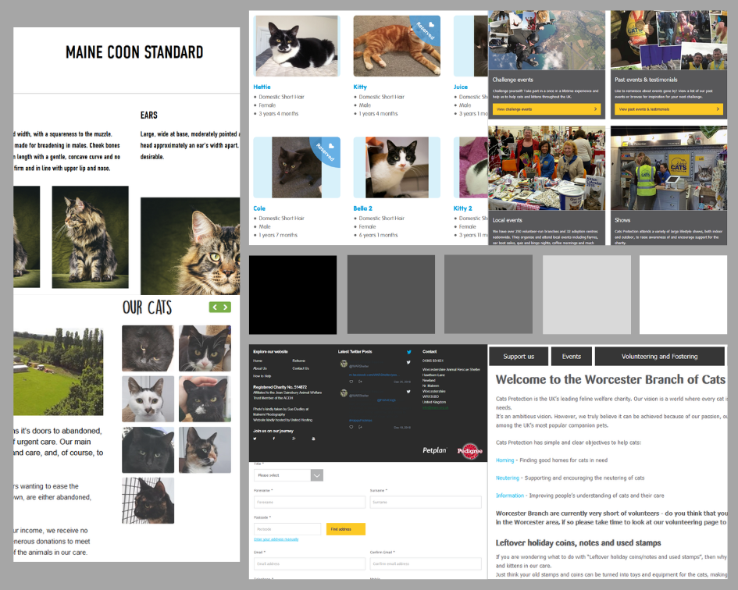

For my mood board, I stuck to a monochromatic theme to keep my site easy to read, and the font clear and concise. Alongside readability, this colour theme was chosen to make my site accessible to those who may be colour blind, making reading coloured text hard, or impossible, avoiding the “fruit salad” approach resulting in a cluttered appearance, and keep mis-convergence and perceptual meanings to a minimum (Muter P, 1996). These along with the following ultimately led to finalising my theme as monochrome:

* Wavelength Separation
* Colour purity
* Brightness
* Stimulus size
* Brightness adaptation level
* Number of colours
* Background (light vs. dark)
* Stimulus location (central vs. peripheral)
* Type of discrimination (relative vs. absolute)
* Individual differences (e.g., age).

(Silverstein, 1987)

The only time in which a separate colour was used, was to place emphasis on certain formats, such as the links within product pages to relevant videos, or to external sites such as twitter.

**Wireframes**

**Index Page:**

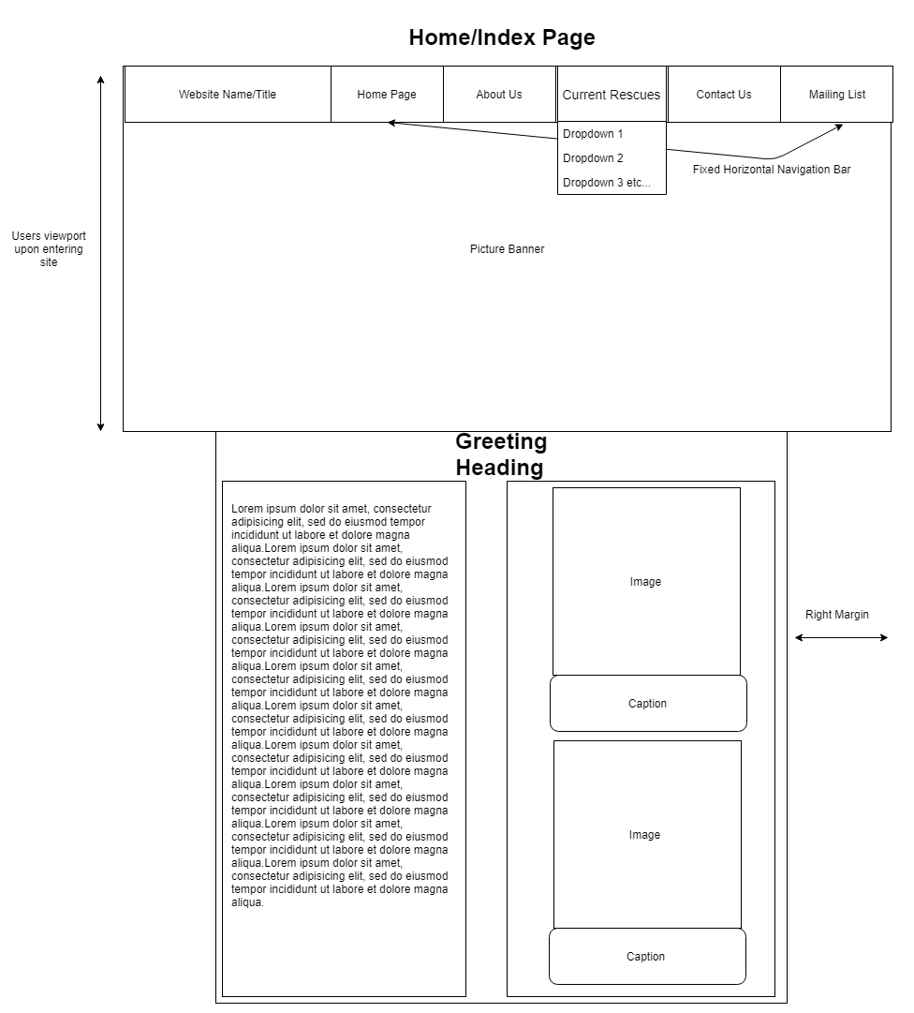

**About us page:**

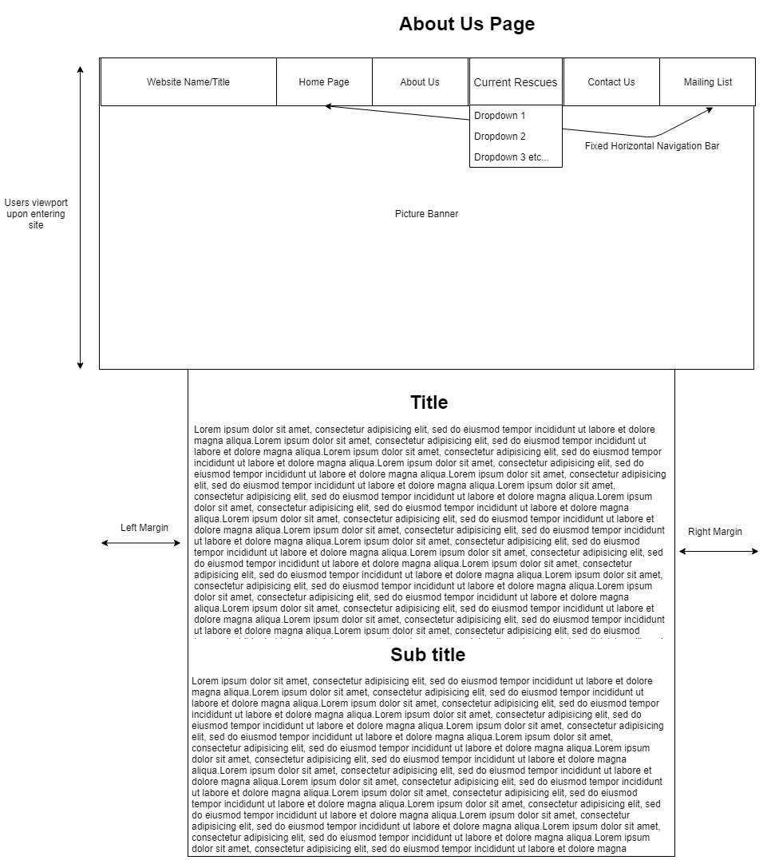

**Contact us page:**

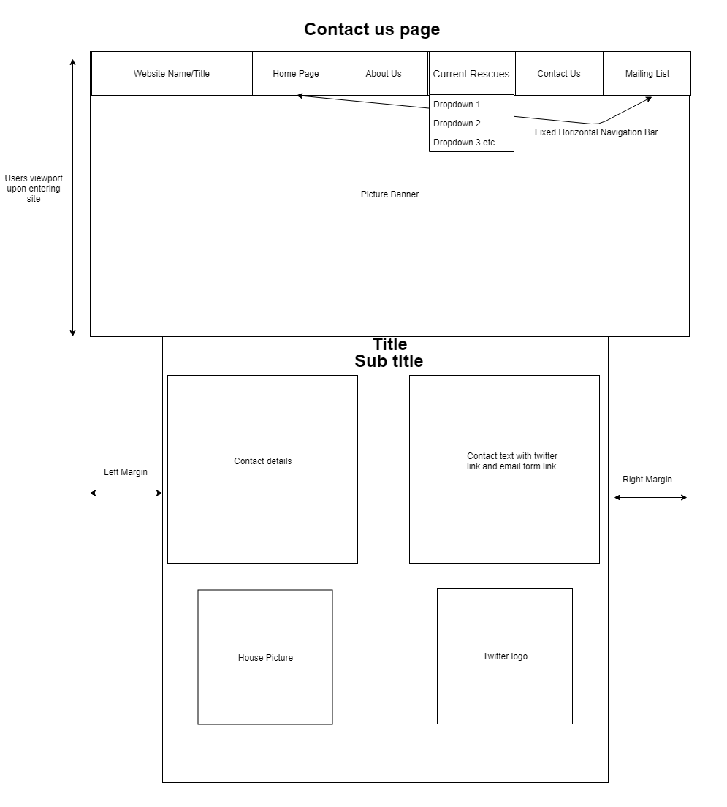

**Product Page:**

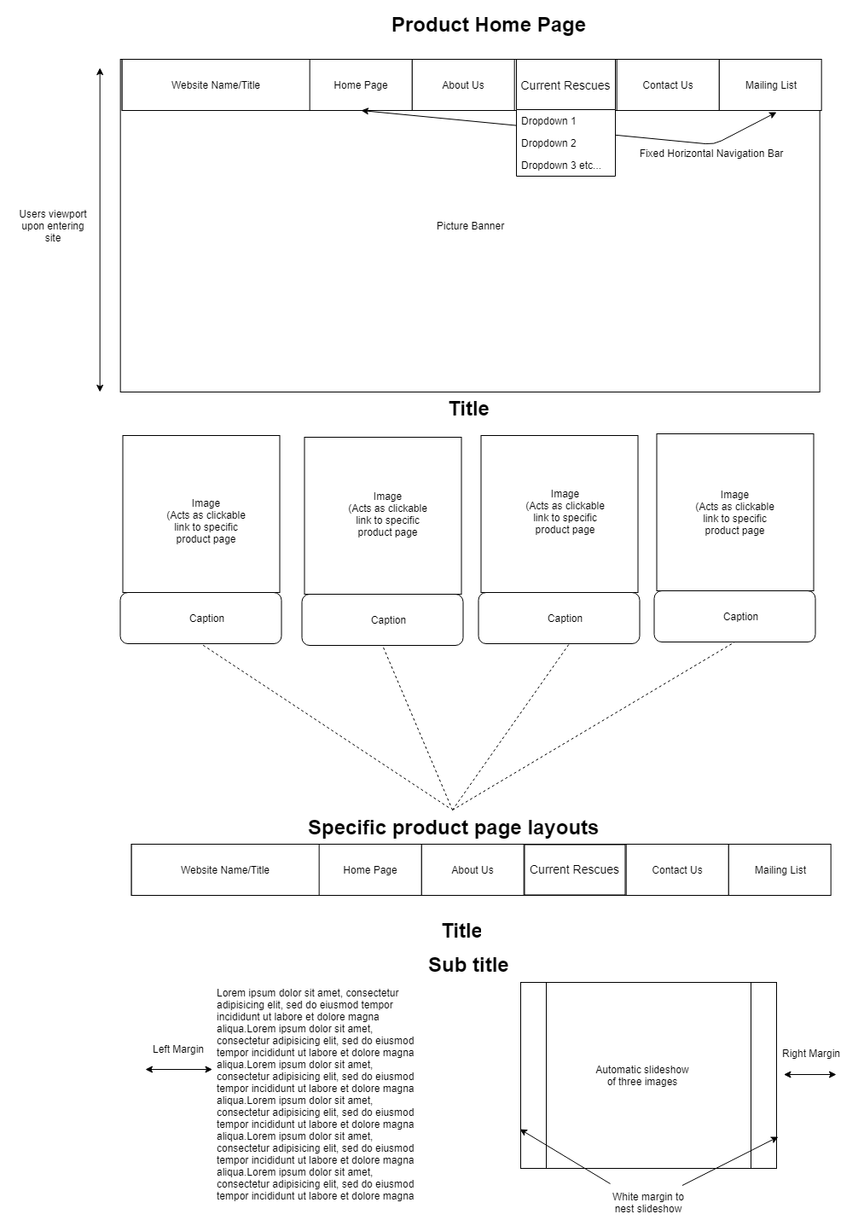

**Mailing list page:**

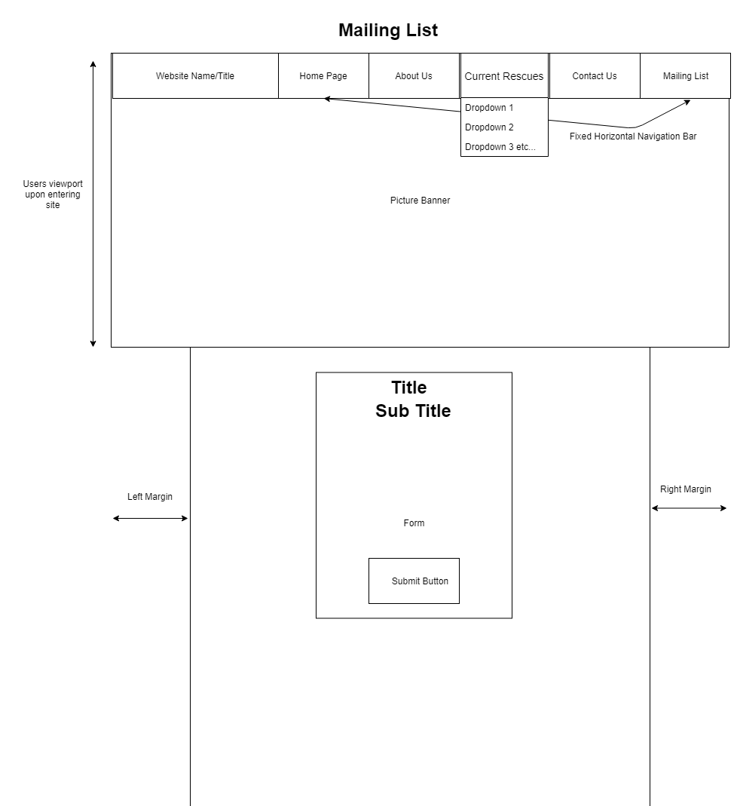

**Screenshot of the final Website and screenshot of commented code**

**Final Website Screenshot (Home/Index Page)**

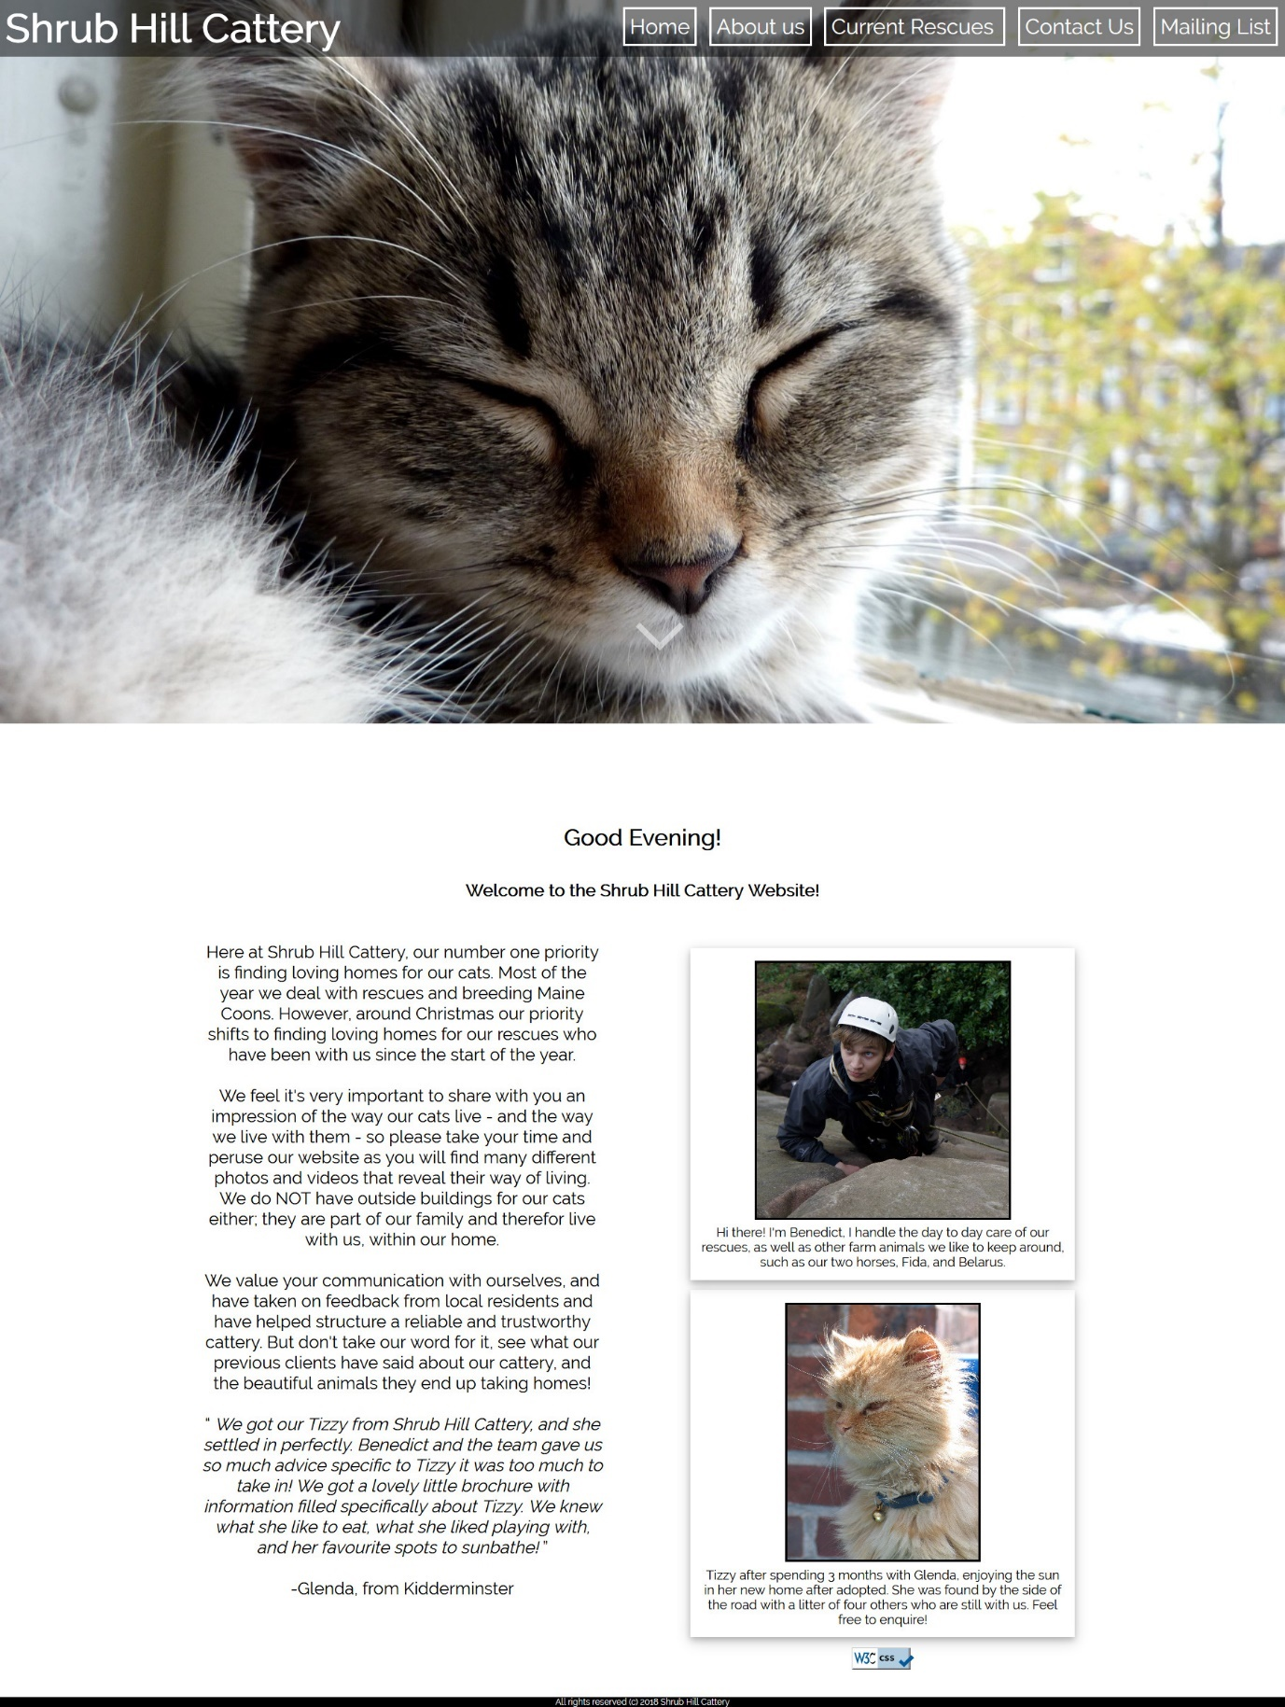

**Commented HTML Code (Home/Index Page)**

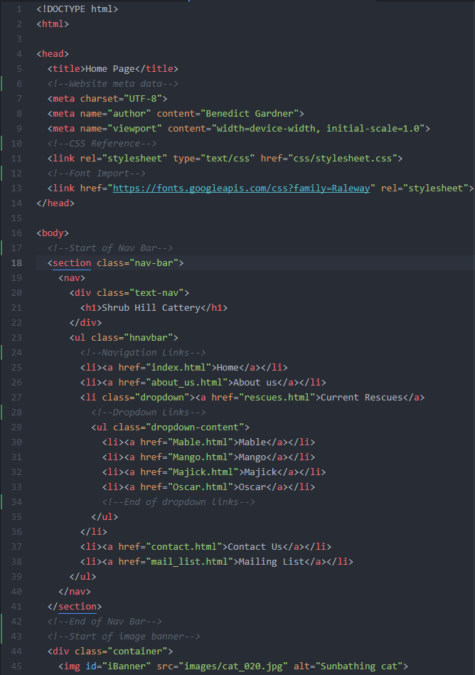

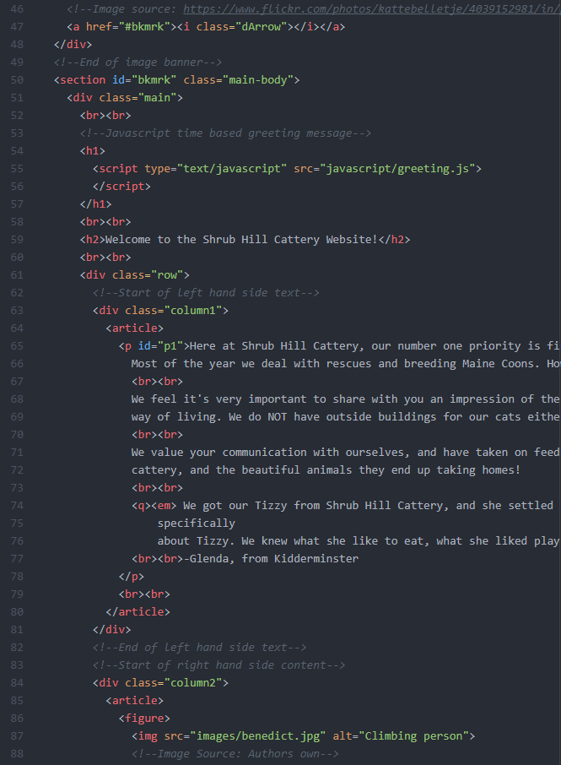

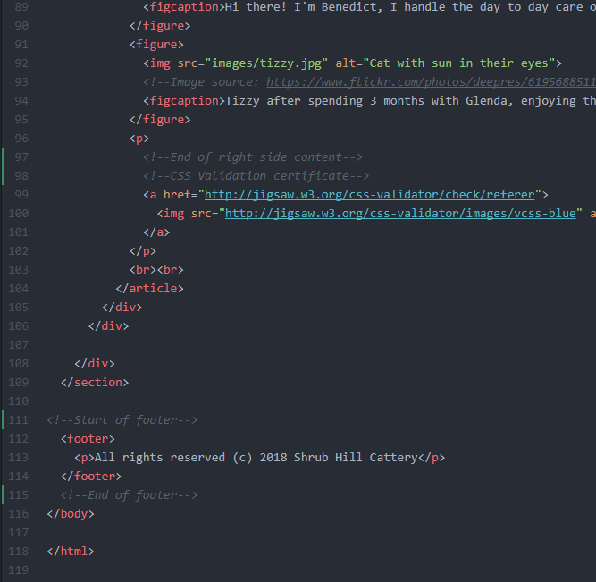

**References:**

* W3Schools “Browser Display Statistics” [Online] Available at: <https://www.w3schools.com/browsers/browsers_display.asp> [Accessed 20th December 2018]
* W3Schools “Automatic Slideshow” [Online] Available at: <https://www.w3schools.com/howto/tryit.asp?filename=tryhow_js_slideshow_auto> [Accessed 20th December 2018]
* Jon Duckett (2014) “JavaScript and jQuery – A basic function” [Book] Pg. 89 [Accessed December 20th, 2018]
* Speeday125 (2013) “email match with confirm email address in contact form” [Online] Available at: <https://stackoverflow.com/questions/18223467/email-match-with-confirm-email-address-in-contact-form> [Accessed 20th December, 2018]
* Google Fonts “Raleway” [Online] Available at: <https://fonts.google.com/specimen/Raleway> [Accessed 1 Jan. 2019]
* MetatronEyes Maine Coons (2019). *MetatronEyes Maine Coons*. [Online] Available at: <http://www.metatroneyes.com/> [Accessed 1 Jan. 2019]
* Bluecross.org.uk (2019). *Blue Cross | Blue Cross | Animal Charity helping sick, injured and homeless pets since 1897.*.. [online] Available at: <https://www.bluecross.org.uk/> [Accessed 1 Jan. 2019]
* Cats.org.uk (2019). *Cats Protection - UK’s Largest Feline Welfare Charity*. [Online] Available at: <https://www.cats.org.uk/> [Accessed 1 Jan. 2019]
* Moore, G. (2019). *Worcestershire Animal Rescue Shelter*. [Online] Wars.org.uk. Available at: <http://www.wars.org.uk/> [Accessed 1 Jan. 2019]
* Codeboxr (2019). “*Top 10 Google Font for Better Readability”*. [Online] Available at: <https://codeboxr.com/top-10-google-font-for-better-readability/> [Accessed 3 Jan. 2019].
* Asha23 (July 30th, 2013). “Country Dropdown List” [Online} Available at: <https://gist.github.com/asha23/6112572> [Accessed November 10th, 2018].
* Torsten Behrens (May 29th, 2018). “Snooze Cat Bokeh” [Online] Available at: <https://www.flickr.com/photos/torsten-behrens/42384417672/in/photolist-27zndHW-TWnhjk-FtYv7i-rbiiWD-nuDreg-TkEVYz-CFf2EQ-ReSpgQ-A5yuY-kLXxMq-5fR9pi-3vy9a-7yRoaU-mG8Zqx-ok5VXt-rgBNGV-mLryRm-28x4Y77-9AaicJ-pA9o7E-DwiTPk-oyYgYB-o49RmT-39TWv6-aFy6ki-2bBwuTQ-2bVHN88-dUtpsb-dirH62-nSLm2G-f1842e-pwqDBj-9GyNJz-4ncZKv-5acoYL-pfiTmB-ibvo62-TTQ9hp-jtDHvG-dTRSs1-bwYsd3-5SJVDf-HU9izW-4ti94a-fFhkPe-kn2pJr-7yMSEe-TugvDV-4vS4Hf-p7vzWi> [Accessed 14th December 2018].
* Tim Zim (April 15th, 2008). “Thatched Cottage” [Online] Available at: <https://www.flickr.com/photos/timzim/2417258942/in/photolist-4FB5Sj-8sBirQ-6LKDKZ-4hakh4-9S8RWc-2xfd5K-dbh5so-mNftc-oDSYrS-2xjGjq-avVMPT-8Jm3wS-84EAmK-nSP3b-b72Br2-Ey9jY-7icbQ1-8gD7Wh-3Sbki-91xHtt-jemhY1-ifMbvU-5uELbQ-876yDL-hc4Mjv-854EMA-7i8i28-dM915T-da2GMq-6ZUnQX-771zpA-4SydGj-4S2H52-8Li33s-8Hzevk-ak1rwF-aiwt8i-56pyZ6-82XjaU-b72vmc-hcmFjw-7734dQ-qF73eM-6V4wqE-6Qy4tu-2bQahod-ojZNz9-a84whu-o1XDjj-5piNab> [Accessed 14th December 2018].
* Paul Snelling (March 18th,2009). “Twitter Logo” [Online] Available at: <https://www.flickr.com/photos/paulsnelling/3398226971/in/photolist-6bhNuc-ggVnE2-6RgzrA-i61Joe-5WY2Du-6TaS6s-aXRMYK-4CDJF6-8cyGzJ-6Nq78r-7NYRn4-6f1yWc-5dwfrN-61RVr7-fn6eiH-5CGqjK-gimnuz-8TaaBn-D1DM6-4HtnK6-i6LbWv-8DzCHa-6Z16J6-8gFRrJ-7WCyEc-7ntuTB-7yrRTQ-NnCVW-5qtbaW-5J2SoD-e4neKv-f5pyPz-9Rskob-7zn3LF-5VSMdG-7FpLtx-6oeqE7-96h9SZ-4b5K4p-4VFrei-a1yuYk-69cP9q-4vj5ws-ajDWV9-6giMAa-pRr2Bq-3cbszp-5CqRHV-6Bxfdw-4QHuYQ> [Accessed 14th December 2018].
* Kattebelletje (October 19th, 2009). “Cat” [Online] Available at: <https://www.flickr.com/photos/kattebelletje/4039152981/in/photolist-79VHsD-daswEJ-7CNHMY-atupd6-7EQcoF-Z7NtKA-eDB6xg-fCv2CA-fSny3M-fPpqfw-7fyRQu-kL8Fcc-5w5Goo-4WDvTp-JAytif-7oSRQc-6qsJ5N-oTnC8k-6jcJZW-39TWv6-2bC5cC2-ehMvLa-9x45s6-a4txfJ-ehMvK6-7kzBWY-2bE9KNs-Deyhzz-2YWuj2-dk2zGY-YccidV-Ea2e9Y-8pZWrs-FHtxS-7bTWA-7zh6HG-drSZn2-q9tTXu-4Nqr5X-5pdktf-boCyAj-KqT1Zd-9r7Phn-7cNSVc-3mHP19-EXaZES-FLKBga-KMBTKf-9U4WcQ-EXmJZB> [Accessed 14th December 2018].
* Artis Logins (August 28th, 2011). “Cat” [Online] Available at: <https://www.flickr.com/photos/mextech/6093923823/in/photolist-ahuXf8-uYQ2H-aqXBdH-hDVqdM-2aCm4MT-atBJxp-79VHsD-daswEJ-7CNHMY-atupd6-7EQcoF-Z7NtKA-eDB6xg-fCv2CA-fSny3M-fPpqfw-7fyRQu-kL8Fcc-5w5Goo-4WDvTp-JAytif-7oSRQc-6qsJ5N-oTnC8k-6jcJZW-39TWv6-2bC5cC2-ehMvLa-9x45s6-a4txfJ-ehMvK6-7kzBWY-2bE9KNs-Deyhzz-2YWuj2-dk2zGY-YccidV-Ea2e9Y-8pZWrs-FHtxS-7bTWA-7zh6HG-drSZn2-q9tTXu-4Nqr5X-5pdktf-boCyAj-KqT1Zd-9r7Phn-7cNSVc> [Accessed 14th December 2018].
* Miranda Brown (November 16th, 2014). “Cat” Available at: <https://www.flickr.com/photos/toastbuster/15621197227/in/photolist-pNoHGF-hRzzDS-gbbWEp-9mbYHd-A5yuY-MTMWwh-5tnwo6-e1MRFf-fUJZLh-armAo-p3f8QV-2Tvy9b-66gS9T-4ggNxS-7YS43R-e5mxUK-biZQxZ-4iLRg6-huCNa-nKoSoS-9gCmDJ-c5D6VS-a8GCMx-ruLwrF-8o2Ao-7S7sBa-o2qdsE-8L2zBV-JM8WoB-atbTYY-LibSky-f2eVi4-mLryRm-6Adwzp-2Vi1Xd-5Pd8Bq-dqnTcV-2jtVQd-23qmn4J-9Atu7g-6W3sn5-4S6qjX-5GriPw-NdEm-a3boYu-efn7Ud-inuhf-5obD5E-9i8SyG-46CaTv> [Accessed 14th December 2018].
* Thryn (February 16th 2016). “Cat” Available at: <https://www.flickr.com/photos/zzilch/25043645012/in/album-72157664261057236/> [Accessed 14th December 2018].
* Muter, P (1996). “Interface design and optimization of reading of continuous text”. In *Cognitive aspects of electronic text processing* [Online] Available at: <http://cogprints.org/753/1/pmuter1.htm> [Accessed 1st January 2019].
* Silverstein, L.D. (1987). “Human factors for colour display systems: Concepts, methods, and   
  research” [Achieved: Colour and the computer. London: Academic Press] Available at: <https://dl.acm.org/citation.cfm?id=49357> [Accessed 1st January 2019]